K Bharath Sanjay
192512324

Exp No: 18 GENERATION OF PWM USING TIMER INTERRUPT
AIM:
To generate PWM using Timer interrupt.
APPARATUS / SOFTWARE REQUIRED:
• PC with Windows OS
• Keil µVision IDE
• 8051 Simulator (Keil built-in)
• Serial Window (UART #1)
PROGRAM:
#include <reg51.h>
sbit PWM = P1^0;
unsigned char count = 0; unsigned char duty = 100; // Change this value (0–200)
void timer0_ISR(void) interrupt 1
{
TH0 = 0xFC; // Reload for 1ms delay
TL0 = 0x66;
count++;
if(count < duty) PWM = 1; // ON time else
PWM = 0; // OFF time
if(count >= 200) // Total period = 200ms
count = 0;
}
void main() {
TMOD = 0x01; // Timer0 Mode 1 (16-bit)

TH0 = 0xFC; // 1ms preload
TL0 = 0x66;
IE = 0x82; // EA = 1, ET0 = 1
TR0 = 1; // Start Timer0
while(1);
}
OUTPUT:
50% Duty cycle:
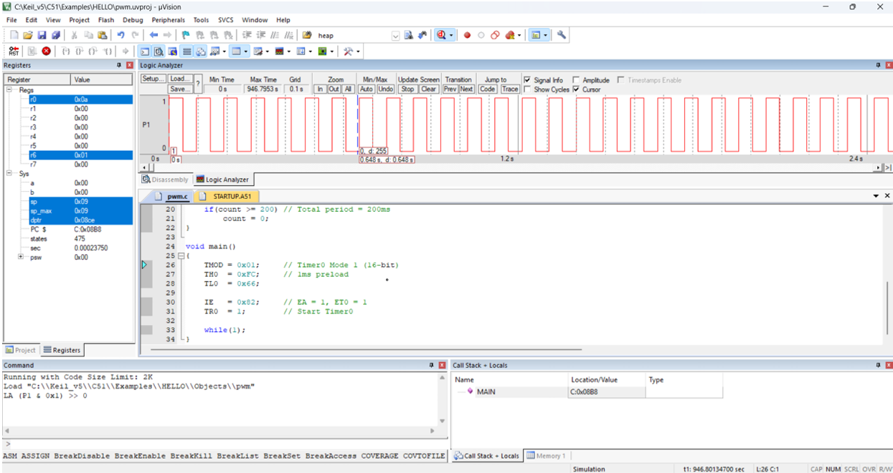
25% duty cycle:
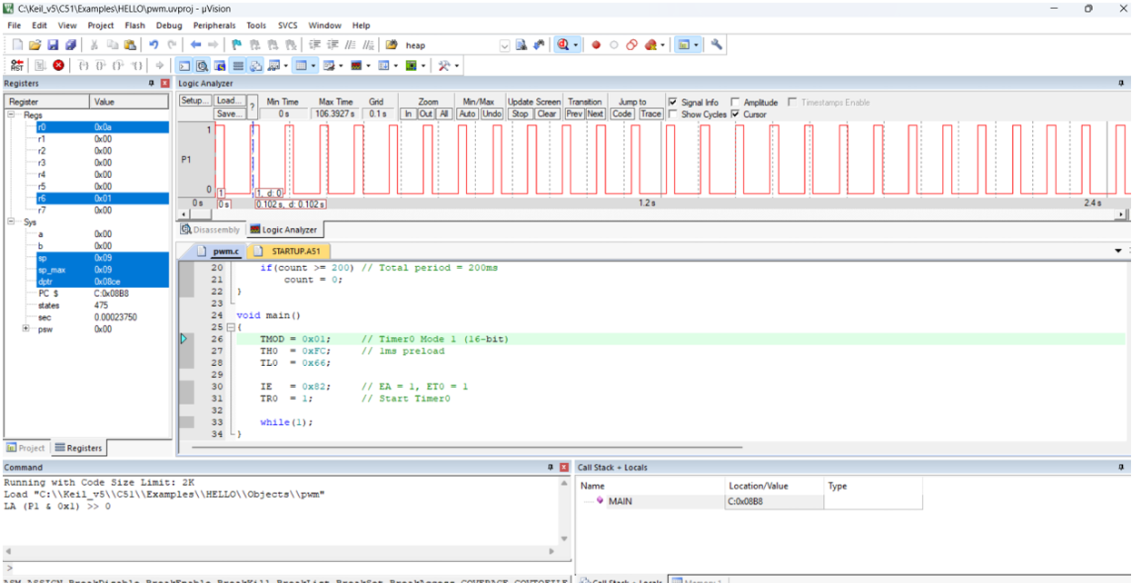
75% duty cycle:
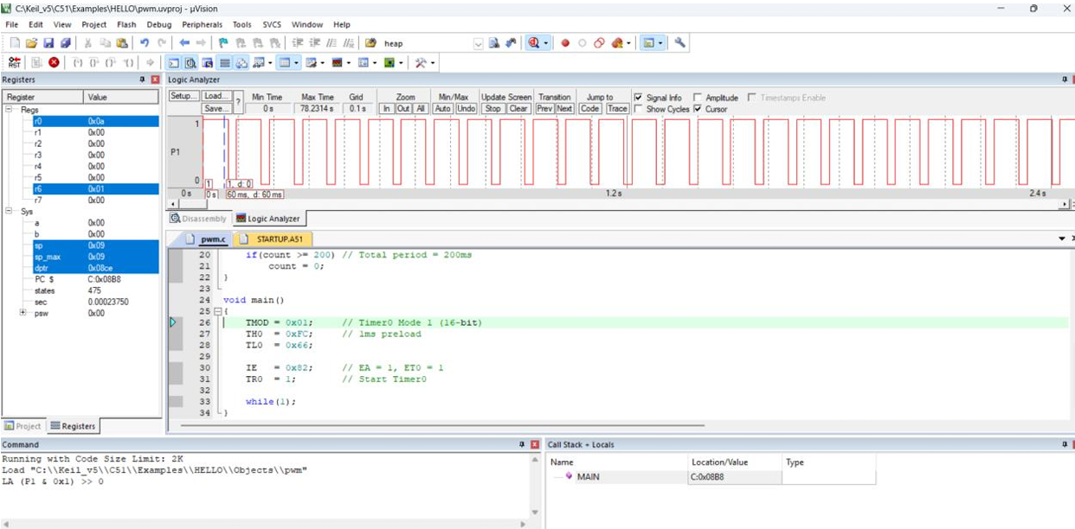
How to Change Duty Cycle:
Total period = 200 ms
Interrupt = 1 ms

